ICICTE MANUSCRIPT PREPARATION GUIDELINES

APA 7th EDITION

Please submit your paper as a Microsoft Word document, or as an open source version of the same (e.g., LibreOffice), in order to utilize the built-in accessibility features available in those word-processors. While we will adhere to APA guidelines for citation, references, and the identification of figures and tables, in the spirit of accessibility and ease of use we are requesting use of your word-processor’s built-in heading styles and table formats.

APA guidelines seem to assume that writers do not have styles or colors or multiple fonts available to them, and that they cannot create vertical lines, as if they were using manual typewriters. In particular, utilizing heading styles will make it easier for authors to verify the information hierarchy within manuscripts, and easier for the editors to check for accessibility and to standardize the appearance of manuscripts in the proceedings.

General Text and Margins Format
- Top & bottom margins: 1 inch
- Right & left margins: 1.5 inches
- Single spaced
- Body Text Font: 12 pt. Times New Roman
- Headings Fonts (select a heading style). The title and headings in this document represent the styles we are using in the proceedings.
  - Title: all caps, Calibri Light Heading, 16 pt, black, centered
  - Heading 1: Calibri 16 pt, blue, centered
  - Heading 2: Calibri Light Heading, 14 pt, blue, left justified
  - Heading 3: Calibri Light Heading, 12 pt, black, left justified
  - Heading 4: Calibri Light Heading, 12 pt, black, italicized, left justified
- Body text left- and right-justified
- References left-justified, with a hanging indent of .5”
- Please do not insert running headers or footers as your manuscript, if accepted, will become part of a larger volume.

Title of the paper
The title should be totally upper-case, centered at the top of the first page. Utilize the “Title” style in your word-processing program. The exact style can be adjusted by the editor.

Author(s) identification
Centered below the title. Identification information is to include name/s, affiliation/s, and country. Utilize the “Body Text” style in Word.

Abstract
Heading “Abstract” as a Level 1 heading, centered under author information. Abstract text should be 50–100 words.

Headings
Please utilize your word-processor’s built-in styles. The appearance of the headings in this document are an example of what they will look like upon publication. The editors will standardize the appearance after your manuscript is submitted. You can verify heading level in these guidelines and your own manuscript by selecting a heading and noting the heading level in the “styles” pane of your word processor.

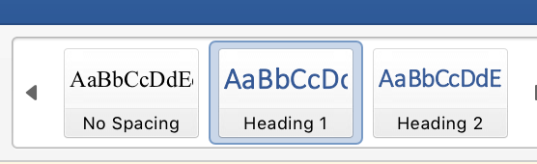

All major sections should have introductory paragraphs (i.e., headings should not come one after another without text in between). The headings do not need to be numbered.

This is a Heading Level 1 (H1)
In these guidelines, a Heading 1 is Calibri, 16 pt, dark blue, centered, with main words capitalized.

This is a Heading Level 2 (H2)
In these guidelines, a Heading 2 is Calibri Light, 14 pt, dark blue, left-justified, with main words capitalized.

This is a Heading Level 3 (H3)
In these guidelines, a Heading 3 is Calibri Light, 13 pt, black, left-justified, with main words capitalized.

This is a Heading Level 4 (H4)
In these guidelines, a Heading 4 is Calibri Light, 12 pt, black, italicized, left-justified, with main words capitalized.

An Example of Manuscript Style

TEACHING WITH TECHNOLOGY—VIRTUAL CLASSROOMS FOR DEAF AND HARD OF HEARING PRIMARY SCHOOL STUDENTS

Nancy Pyrini
1st Primary School of Rafina
GREECE

Abstract
This paper describes the design, development, and implementation of instructional methods that introduced teaching with technology in virtual classrooms to deaf and hard-of-hearing students in a metropolitan Athens elementary school. Results include…

Description of the Project (H1)
Before describing the project's targets and specifications, some definition of terms is necessary.

Definitions (H2)
Two of the key terms used in describing the project require definition. The first term is…

Targets and Specifications (H2)
The targets and specifications of the project focused on several key areas...

Equipment and Software (H3)
Equipment for each site consisted of ...

Training Staff (H3)
Training staff in the use of ICT was required because…

Facilitators (H4)
Facilitators led discussions with other staff members about the use of ICT…

The easiest way to verify that your heading styles are accurate is to insert a Table of Contents (the method might depend upon the version of your word-processor) and include each level of heading style that you utilize in your paper. You do not need to leave this Table of Contents in your manuscript – it is just to facilitate a self-check.

In-text Citations
In-text citations should use the author-date style of APA (Publication Manual of the American Psychological Association) 7th edition. Source citations for direct quotations must provide page numbers as well as author(s) and date.

Notes
If there are any notes, these are to be numbered consecutively and placed at the end of the paper, before the References section in a section called Notes. Please do not use the computer’s footnote or endnote function. Instead, use the Superscript in the text and numbering function in the Notes.


References
Manuscripts should use APA style (7th edition) where sources appear in a References section; all sources must be referred to in the text. References need to include complete information: date, page numbers of articles or chapters, and complete names for institutions and organizations rather than abbreviations or acronyms. References from conferences or other Proceedings also need page numbers.
References use a hanging indent paragraph style (indented .5) as shown in the reference examples below. Please use “hanging indent” paragraph style rather than adding spaces.

Please note:
- In APA style, for books and articles, only first word of title, proper nouns, and the first word following a colon (:) in the title are capitalized.
- A journal title is in italics, as is the volume number.
- The abbreviation “pp.” is not used before the page numbers of a journal article; however, it is used before the page numbers of a chapter or article in an edited work.

For assistance, consult the Purdue online Writing Lab page on the use of APA documentation style.

Book – one author
Bates, A. W. (1995). Technology, open learning and distance education. London: Routledge.

Journal article
Ash, C. (2000). Towards a new cost-aware evaluation framework. Educational Technology and Society, 3(4), 126–131.
Jones, A., Scanlon, E., Tosunoglu, C., Morris, E., Ross, S., Butcher, P., & Greenberg, J. (1999). Contexts for evaluating educational software. Interacting with Computers, 11(5), 499-516.

Article/chapter in an edited work
Frost, S. H. (2000). Historical and philosophical foundations for educational advising. In V. N. Gordon & W. R. Habley (Eds.), Academic advising: A comprehensive handbook (pp. 3-17). San Francisco: Jossey-Bass.

Conference Proceedings
Wolfson, G. K. (2002). Creating and sustaining learning communities: The electronic learning community. In K. Fernstrom (Ed.), The 3rd International Conference on Information Communication Technologies in Education (pp. 141-148). Athens, Greece: The National and Kapodistrian University of Athens.

Electronic source
University of Hong Kong. (1997, June). Final report: Ad Hoc Group for Learning Technologies. Retrieved from http://www.hku.hk/caut/Homepage/itt/5_Reports/5_1AdHoc.htm
Note: the date of retrieval is not provided in APA references. If a DOI number is available, please include it at the end of your reference.

From a private organization
American Psychiatric Association. (2000). Practice guidelines for the treatment of patients with eating disorders (2nd ed.). Washington, DC: Author.

Tables and Figures
All figures and tables need to be referred to at the appropriate points in the text. They should be embedded in consecutive order in the manuscript (i.e., not all grouped together at the end) in the logical location for easy reference. Figures and tables should be numbered in order throughout the text, and each requires a title or caption.
Capitalize all references to tables and figures, e.g.:
- “...the number of users is greater, as shown in Figure 1.”
- “(see Table 2 below.)”
For reasons of accessibility:
- Use tables only to present data, not to format your pages. Include headings in each table.
- Tables should not be screen captures (images) but the actual tables themselves, so the information in a particular cell can be selected or searched for.
- Figures that are shared as images should include descriptive information in an alt tag so that any reader has access to the key information in the figure.

Copyright Information for Tables and Figures
If you are reproducing a graphic, chart, or table, from some other source, you must provide a special note at the bottom of the item that includes copyright information. Also submit written permission along with your work. Begin the citation with “Note” in italics followed by a period. If you wish to include a short descriptive statement, insert it after “Note.”

Example from An Article
Note. Adapted from “Towards a New Cost-Aware Evaluation Framework by C. Ash, 2000, Educational Technology and Society, 3, p.128. Copyright 2007 by the International Forum of Educational Technology & Society (IFETS). Adapted (or reprinted) with permission.

Example from a book.
Note. Adapted from Technology, Open Learning and Distance Education (p.27), by A. W. Bates, 1995, London: Routledge. Copyright 1995 by Routledge. Adapted (or reprinted) with permission.

Tables
For a table:
- Type “Table” and its number in boldface on a line by itself above the table. No period after the table number!
- On the next line, provide a table title in italics, not boldfaced. No period after the title!
- Place the table itself flush left.
- Though strict APA style allows only horizontal border lines (remember the typewriter!), for greater readability you can include a full border in your tables (see Tables 1 and 2 below).
- Include a heading row for your table and center the heading over each column.
- For reasons of accessibility, to ensure that the heading is identified by your word-processor as a heading, select the table heading/s, right click to open table properties in your word processor, and select the “Row” tab.
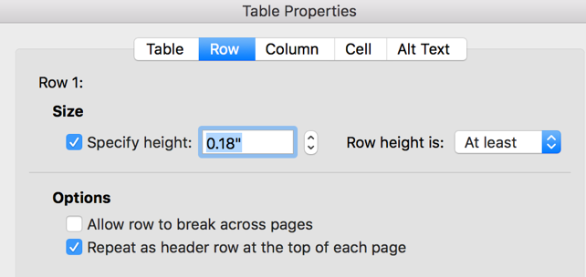

- Then, select “repeat as header row at the top of each page” or the equivalent. Deselect “Allow row to break across pages”. Notice how Table 2 breaks over two pages, and the headings are repeated on the second page.
- Within the table provide 6 pts above and below the headings and the same space between table number and title.
- Where appropriate, indicate sources of data at the bottom of the table, for example, “Source: Smith & Jones, 2001.” You can also provide a “Note” with an acknowledgement (see APA guidelines for more information).

Below are two examples of tables, which would be referenced in the text as “Table 2” and “Table 3”. Do not be concerned if your table “breaks” over a page – this will be addressed by the editors.

Table 1
Populations and Response Rates of On-campus (Full-time) and Distance Learning (Part-time) Students
 | Population | Response | Response Rate
US | 275 | 91 | 33.1%
UNISA | 385 | 78 | 20.1%

Table 2
Frequencies for Questions about Operational Writing Center Problems
 | Tutors
 | Problem Experienced? |  |  | Could be Ameliorated through Collaborative Networking?
Question | Yes | No | Total | Yes | No | Total
- Amount of Feedback Provided | 1 | 4 | 5 | 3 | 2 | 5
- Appointments Schedule Flexibility | 2 | 3 | 5 | 4 | 1 | 5
- Clarity of Feedback Provided to Students | 2 | 3 | 5 | 0 | 5 | 5
- Convenience of Location | 0 | 5 | 5 | 1 | 4 | 5
- Tutor Availability | 3 | 2 | 5 | 4 | 1 | 5
- Other | 3 | 2 | 5 | 0 | 5 | 5
Note. This is where you could include a note with explanatory or copyright information.

Figures
For a figure:
- Place the figure number, e.g., “Figure 1” (or 2 or 3, etc.) flush left.
- On the next line, place the caption, in body text, italicized. The caption should be a brief descriptive phrase.
- Place the figures flush left.
- Where appropriate, indicate sources of data at the bottom of the figure.
- For reasons of accessibility, provide alt text. (explained below).

Figure 1
Interatomic repulsive and attractive forces in metals

For a graphic such as in Figure 1, select the figure, right click, select “Edit alt text,” and then write a description of the figure in the text box such as that written below. This text can be “heard” by a screen reader or read by anyone who looks “behind the scenes”.

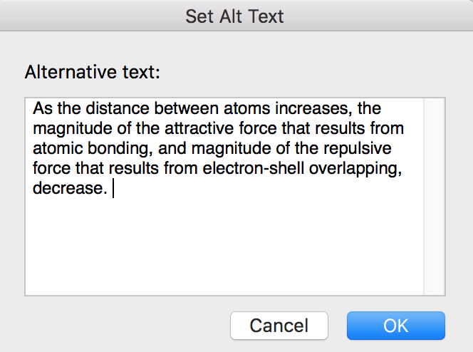

For an image such as that in Figure 2, select “Format picture”, and then select the blue “Layout and Properties” icon. Then, provide “alt text,” not longer than a tweet, to describe the image.

Figure 2
“The Knowledge Tree,” artwork created by the students of Group 2 (ST’2) of the 1st Primary School of Rafina
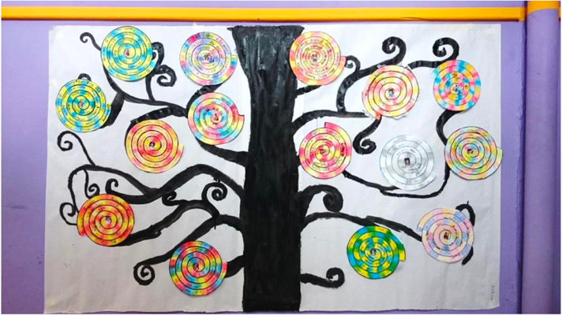

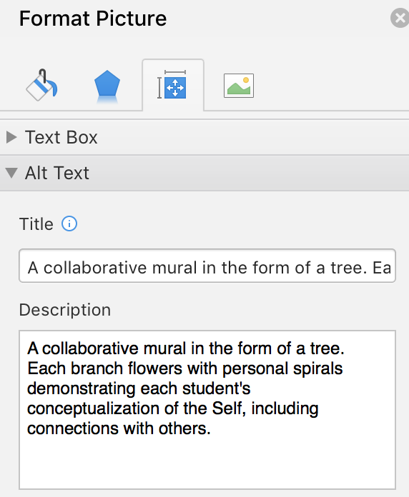

Equations
Equations should be centered on the page, with a blank line above and below. They should be numbered consecutively throughout the paper, using Arabic numbers in parentheses at the right-hand margin.

Lists
Lists, ordered or unordered, should be indented (.5). Unordered lists should be represented with round, black bullets; indented bullets may be appear different. Ordered lists can use numbers or letters.

Other Formatting Conventions

Spelling and Capitalization
Please follow the spelling and capitalization conventions used in the list below:
- the Web or the World Wide Web
- Internet
- email
- e-health
- online
- iPad
- ICT – Information Communication Technologies (plural)

Acronyms and Abbreviations
Acronyms and abbreviations for organizations or agencies should be explained in their first use, such as the University of the Fraser Valley (UFV). To abbreviate the name of an organization or agency to the initial letters, use capitals and no periods.

Use of Italics
Use italics sparingly to identify special terms or to indicate special emphasis.

Hyperlinks and Underlining
- In the body of your paper, text-describe hyperlinks rather than sharing a url in the body of your paper.
  - Do not share the URL: www.icicte.org
  - Instead, text-describe the URL: The International Conference on Information Communication Technologies in Education
- Additional examples are on p. 1 (LibreOffice) and p. 4 (Purdue Online Writing Lab) of these guidelines.
- In the References, share complete URLs.
- Do not use underlining except to signal a hyperlink.

Author details
At the end of the paper, below the references, each author should include:
- Name
- Affiliation
- Email address

Example:
Ġorġ Mallia
Department of Media and Communications
University of Malta
MALTA
info@gorgmallia.com

Questions?

For help, reach out to Litsa Varonis, Lvaronis@gmail.com

